<https://tinyurl.com/27q3en9d>

<https://www.tinkercad.com/things/iPszKJjRNxx-porta-logica-not>

<https://tinyurl.com/2crp3kkk>

<https://www.tinkercad.com/things/fEqPn11UzDG-porta-logica-and>

<https://tinyurl.com/2dqfha68>

<https://www.tinkercad.com/things/0CPeY0ym7IG-porta-logica-or>

<https://tinyurl.com/2xnzertg>

<https://www.tinkercad.com/things/ldoo8qkbiJn-porta-logica-nand>

<https://tinyurl.com/28eudnlz>

<https://www.tinkercad.com/things/4sPxJ2XVc4b-porta-logica-nor>

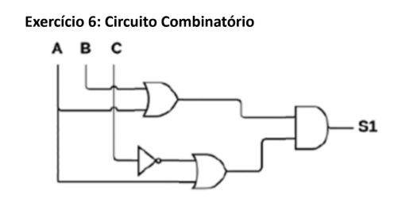

|  |  |  |  |
| --- | --- | --- | --- |
| **A** | **B** | **C** | **SAIDA** |
| **0** | **0** | **0** | **0** |
| **0** | **0** | **1** | **0** |
| **0** | **1** | **0** | **1** |
| **0** | **1** | **1** | **0** |
| **1** | **0** | **0** | **1** |
| **1** | **0** | **1** | **1** |
| **1** | **1** | **0** | **1** |
| **1** | **1** | **1** | **1** |

<https://tinyurl.com/22joyang>

<https://www.tinkercad.com/things/l9wCuSAQfnH-exercicio-6-pratica01>

|  |  |  |  |
| --- | --- | --- | --- |
| **A** | **B** | **C** | **SAIDA** |
| **0** | **0** | **0** | **1** |
| **0** | **0** | **1** | **0** |
| **0** | **1** | **0** | **1** |
| **0** | **1** | **1** | **1** |
| **1** | **0** | **0** | **1** |
| **1** | **0** | **1** | **0** |
| **1** | **1** | **0** | **1** |
| **1** | **1** | **1** | **0** |

<https://tinyurl.com/23rm3fwp>

<https://www.tinkercad.com/things/d9CKf9npWOp-exercicio-7-pratica01>

<https://tinyurl.com/24my42xu>

<https://www.tinkercad.com/things/1P4odCK6130-exercicio-8-pratica01>

|  |  |  |  |  |
| --- | --- | --- | --- | --- |
| **A** | **B** | **C** | **D** | **SAIDA** |
| **0** | **0** | **0** | **0** | **1** |
| **0** | **0** | **0** | **1** | **1** |
| **0** | **0** | **1** | **0** | **1** |
| **0** | **0** | **1** | **1** | **1** |
| **0** | **1** | **0** | **0** | **1** |
| **0** | **1** | **0** | **1** | **1** |
| **0** | **1** | **1** | **0** | **1** |
| **0** | **1** | **1** | **1** | **1** |
| **1** | **0** | **0** | **0** | **0** |
| **1** | **0** | **0** | **1** | **1** |
| **1** | **0** | **1** | **0** | **1** |
| **1** | **0** | **1** | **1** | **1** |
| **1** | **1** | **0** | **0** | **0** |
| **1** | **1** | **0** | **1** | **1** |
| **1** | **1** | **1** | **0** | **1** |
| **1** | **1** | **1** | **1** | **1** |